Test Case for Multi-threading

Requirement to test | Test Data Input | Expected Outcomes | Actual Outcomes
- Save objects to file | Run Program | 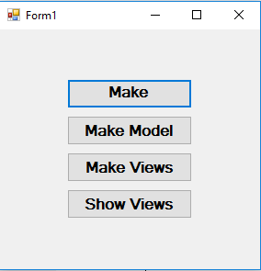 | As expected
 | Run the program and add four objects | 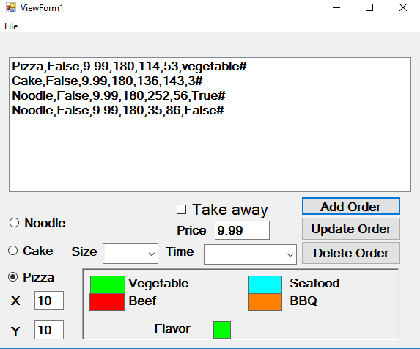 | As expected
 | Press ”File” menu, select “save” | 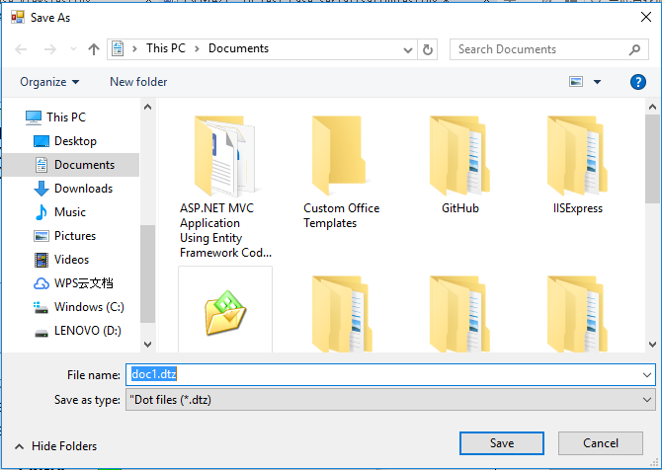 | As expected
 | Press “save” on the dialog pumped out | The save file thread runs | As expected
 |  | A dtz file has been saved, which contains the attributes of the four objects. The objects order in the dtz file is the same with the order in the view. | As expected

